TLD Server
# Source: Chatgpt (GPT-5-Mini) at [1/18/2026]
TLD Server stands for Top-Level Domain Server — it’s a crucial part of the Domain Name System (DNS) hierarchy.

🔹 Role of TLD Servers
# Source: Chatgpt (GPT-5-Mini) at [1/18/2026]
- TLD servers manage the top-level domains (TLDs) such as:
  - .com
  - .org
  - .net
  - .edu
  - Country codes like .uk, .jp, .in
- When you ask for a domain like example.com, after the root DNS servers, your DNS resolver contacts the TLD server for .com to find out which authoritative DNS server holds the records for example.com.

🔁 DNS Lookup Flow (Including TLD Server)
# Source: Chatgpt (GPT-5-Mini) at [1/18/2026]
- Your device asks the root server for www.example.com.
- The root server replies with the TLD server for .com.
- The DNS resolver asks the .com TLD server where to find example.com.
- The TLD server replies with the authoritative DNS server for example.com.
- The resolver queries that authoritative server for the IP address.

🔍 Summary
# Source: Chatgpt (GPT-5-Mini) at [1/18/2026]
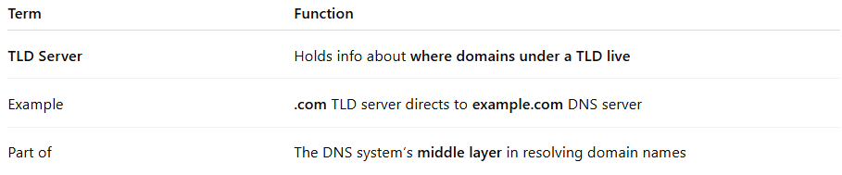

Term | Function
TLD Server | Holds info about where domains under a TLD live
Example | .com TLD server directs to example.com DNS server
Part of | The DNS system’s middle layer in resolving domain names

- It helps organize the internet's namespace by domain type.
- Ensures efficient and hierarchical DNS resolution.

